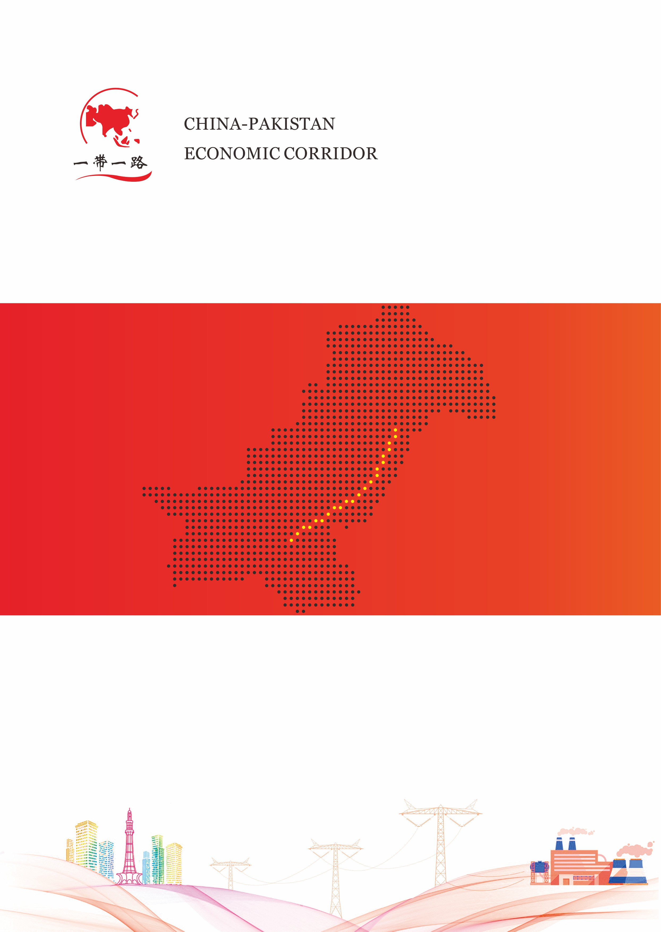

**拉合尔换流站**

**二Ｏ二Ｏ年**

**拉合尔换流站安全工器具借用记录**

拉合尔换流站安全工器具借用记录（**Safety Apparatus Borrowing Record**）

**2020年**

|  |  |  |  |  |  |  |  |
| --- | --- | --- | --- | --- | --- | --- | --- |
| **安全工器具名称**  **Safety Apparatus** | **数量**  **Number** | **借用（Borrow）** | | | **归还（Return）** | | **备注**  **Others** |
| **借用日期及时间**  **Borrow Time** | **借用人及电话**  **Name And Telephone** | **经手人**  **Handler** | **归还日期及时间**  **Return Time** | **经手人**  **Handler** |
|  |  |  |  |  |  |  |  |
|  |  |  |  |  |  |  |  |
|  |  |  |  |  |  |  |  |
|  |  |  |  |  |  |  |  |
|  |  |  |  |  |  |  |  |
|  |  |  |  |  |  |  |  |
|  |  |  |  |  |  |  |  |
|  |  |  |  |  |  |  |  |
|  |  |  |  |  |  |  |  |
|  |  |  |  |  |  |  |  |
|  |  |  |  |  |  |  |  |
|  |  |  |  |  |  |  |  |